CS 340 README Template

Use this template to complete your README file. When completing the template, keep the headings as they are so that your document has a clear organization. Remove the italicized prompt text after you have completed each section for a polished final document.

About the Project/Project Title
Animal Shelter Python Module
The purpose of this project is to create an interactive dashboard for Grazioso Salvare using data from the Austin Animal Center. The dashboard connects to MongoDB through the AnimalShelter CRUD Python module and allows users to filter animals based on different rescue requirements. The dashboard includes an interactive data table, a breed distribution chart, and a map showing the location of selected animals.

Motivation

The goal of this project was to make the animal shelter data easier to search and understand. Instead of manually running MongoDB queries, the dashboard allows users to select a rescue type and automatically displays animals that meet the required breed, sex, and age criteria. Using a reusable CRUD module also keeps the database code separate from the dashboard and makes the application easier to maintain.

Getting Started
The project uses the Austin Animal Center Outcomes dataset stored in MongoDB. The Python dashboard connects to the database through the AnimalShelter CRUD module.
To use the module:

- Make sure MongoDB is running.

Make sure MongoDB is running and the animal dataset has been imported.

Make sure the MongoDB user has permission to access the animals database and collection.

Place CRUD_Python_Module.py and the dashboard Python file in the same directory.

Place the Grazioso Salvare logo in the Dash assets directory.

Install the required Python packages.

Run the dashboard Python file.

Open the local Dash address displayed in the terminal.

Installation
The following tools were used:

- MongoDB: Stores the Austin Animal Center data.
- Python: Provides the main programming language for the application.
- PyMongo: Connects the AnimalShelter CRUD module to MongoDB.
- Pandas: Converts MongoDB results into data that can be displayed and analyzed.
- Dash: Provides the interactive web dashboard.
- Plotly Express: Creates the breed distribution pie chart.
- Dash Leaflet: Displays animal locations on an interactive map

PyMongo and Jupyter Notebook can be installed with the following commands:

pip install pymongo pandas dash plotly dash-leafletpip install notebook

MongoDB must also be installed, running, and configured with the appropriate database user and permissions.

Usage

The dashboard provides four rescue filtering options: Water Rescue, Mountain or Wilderness Rescue, Disaster or Individual Tracking, and Reset. Selecting a rescue type sends the appropriate query through the AnimalShelter CRUD module to MongoDB. The returned animals are displayed in the data table, and the breed chart updates to show the distribution of matching breeds. The map displays the location of the selected animal. Selecting Reset restores the complete dataset.

Code Example

from CRUD_Python_Module import AnimalShelter

shelter = AnimalShelter()

animal = {

"rec_num":111111,

"name":"Mongo",

"animal_type":"Dog"

}

shelter.create(animal)

print(shelter.read({"rec_num":111111}))

shelter.update(

{"rec_num":111111},

{"name":"Mongo Updated"}

)

shelter.delete({"rec_num":111111})

Screenshots
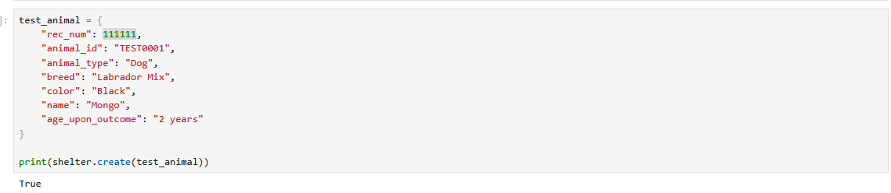
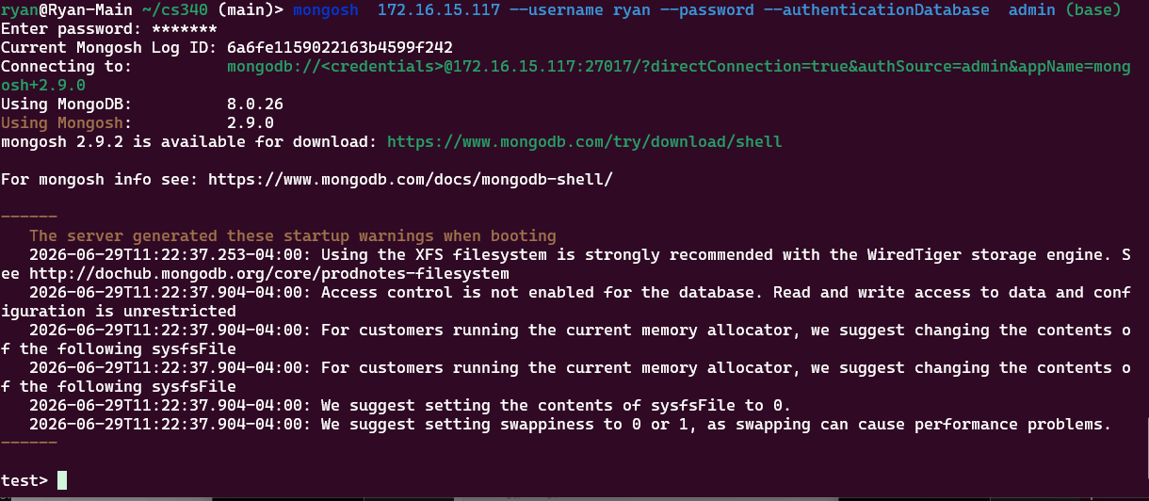
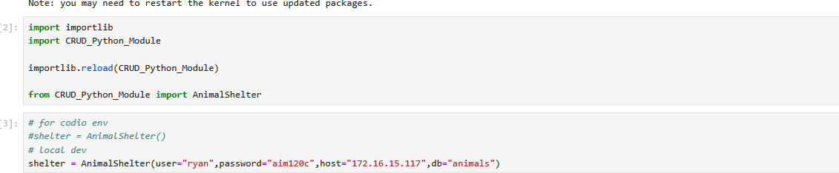
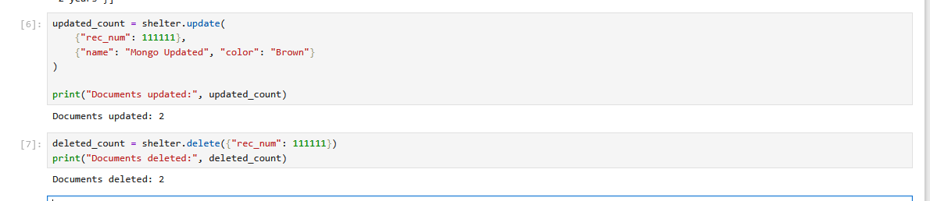
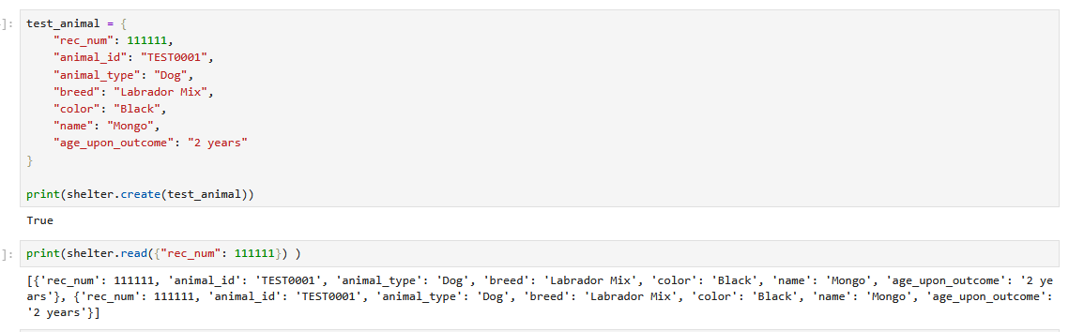
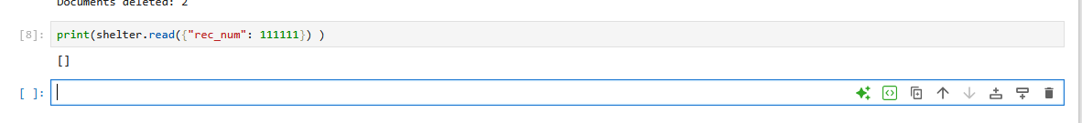
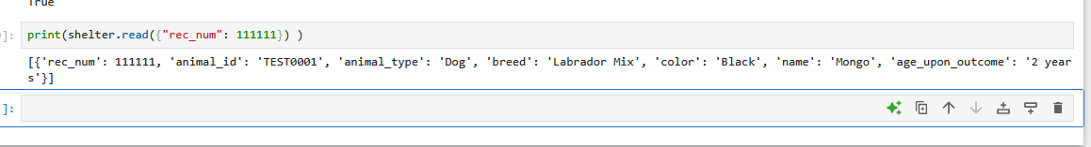
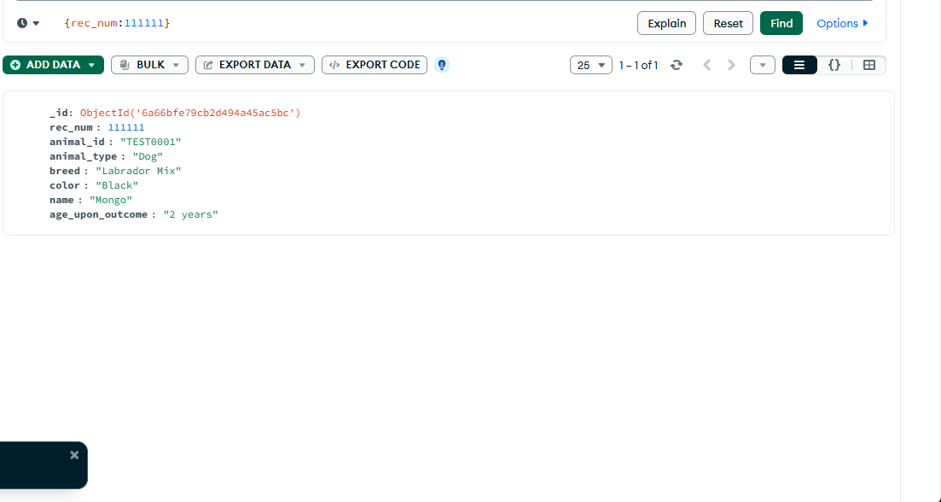
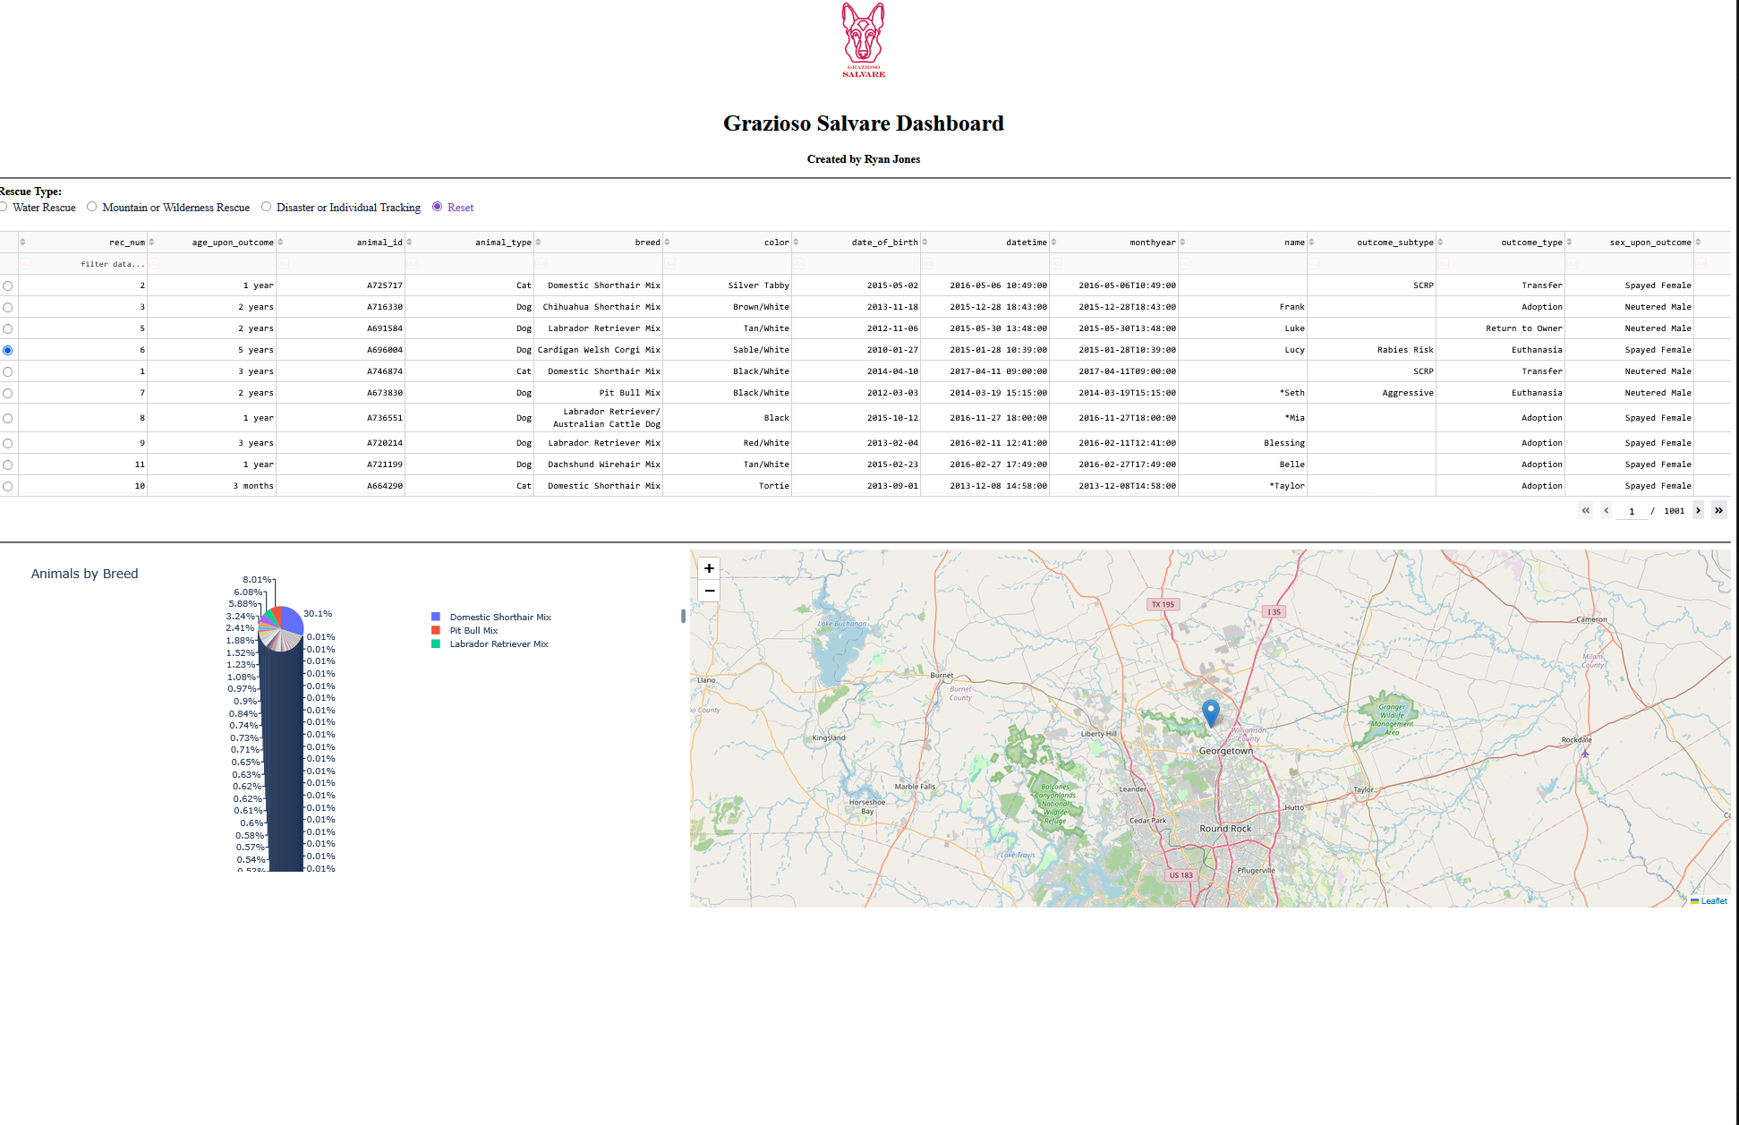
Initial Dashboard

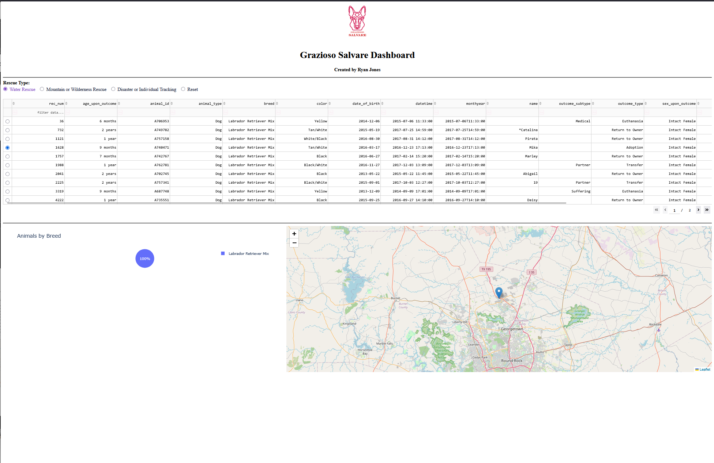
Water Rescue Fileter
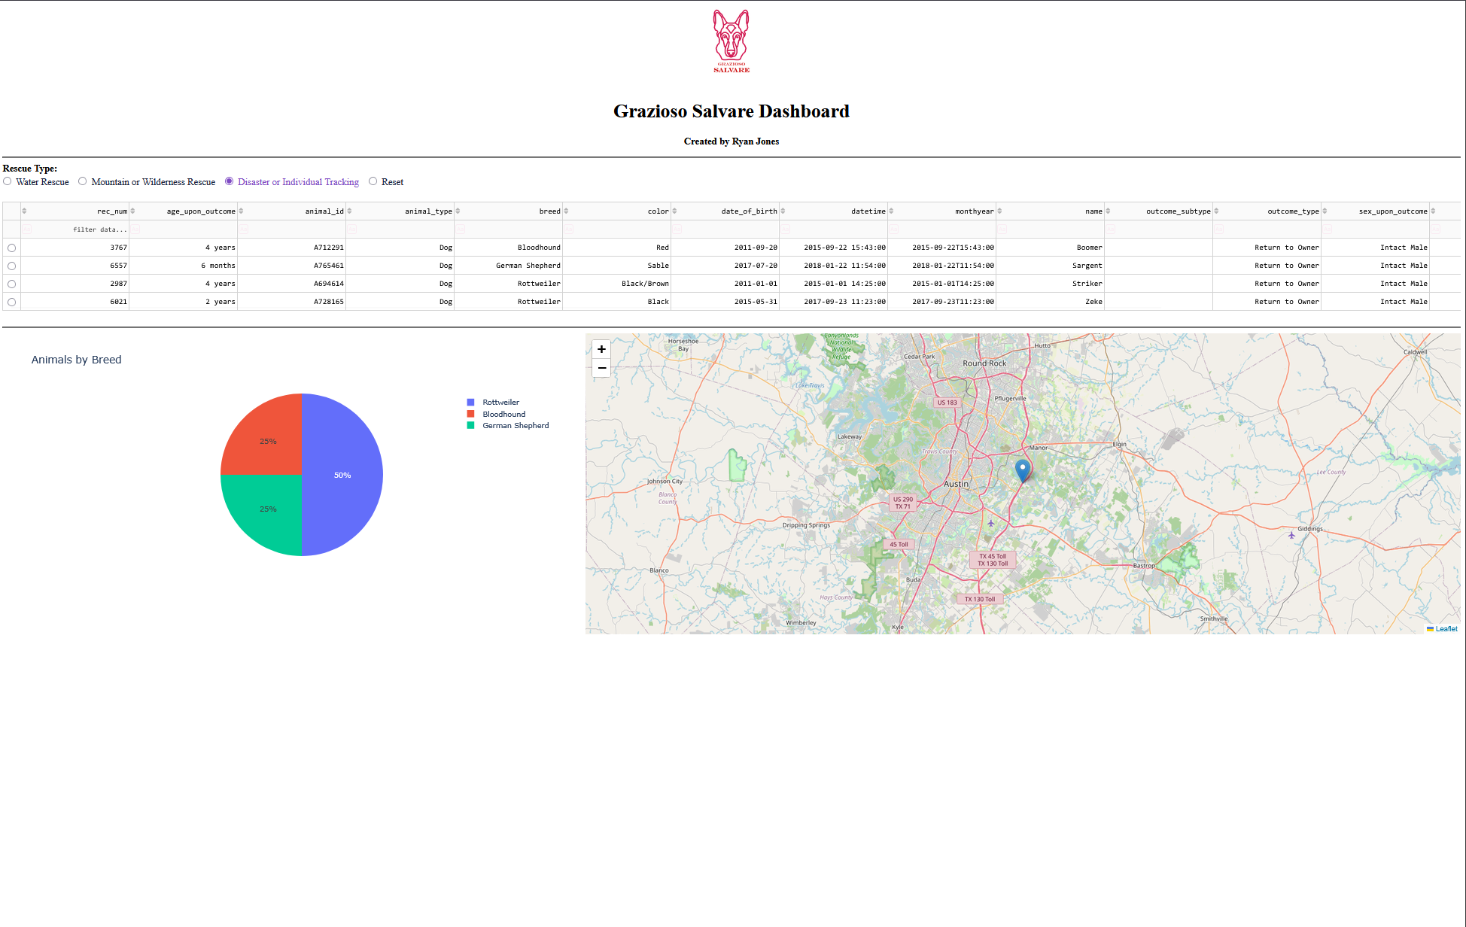
Mountain Rescue Filer
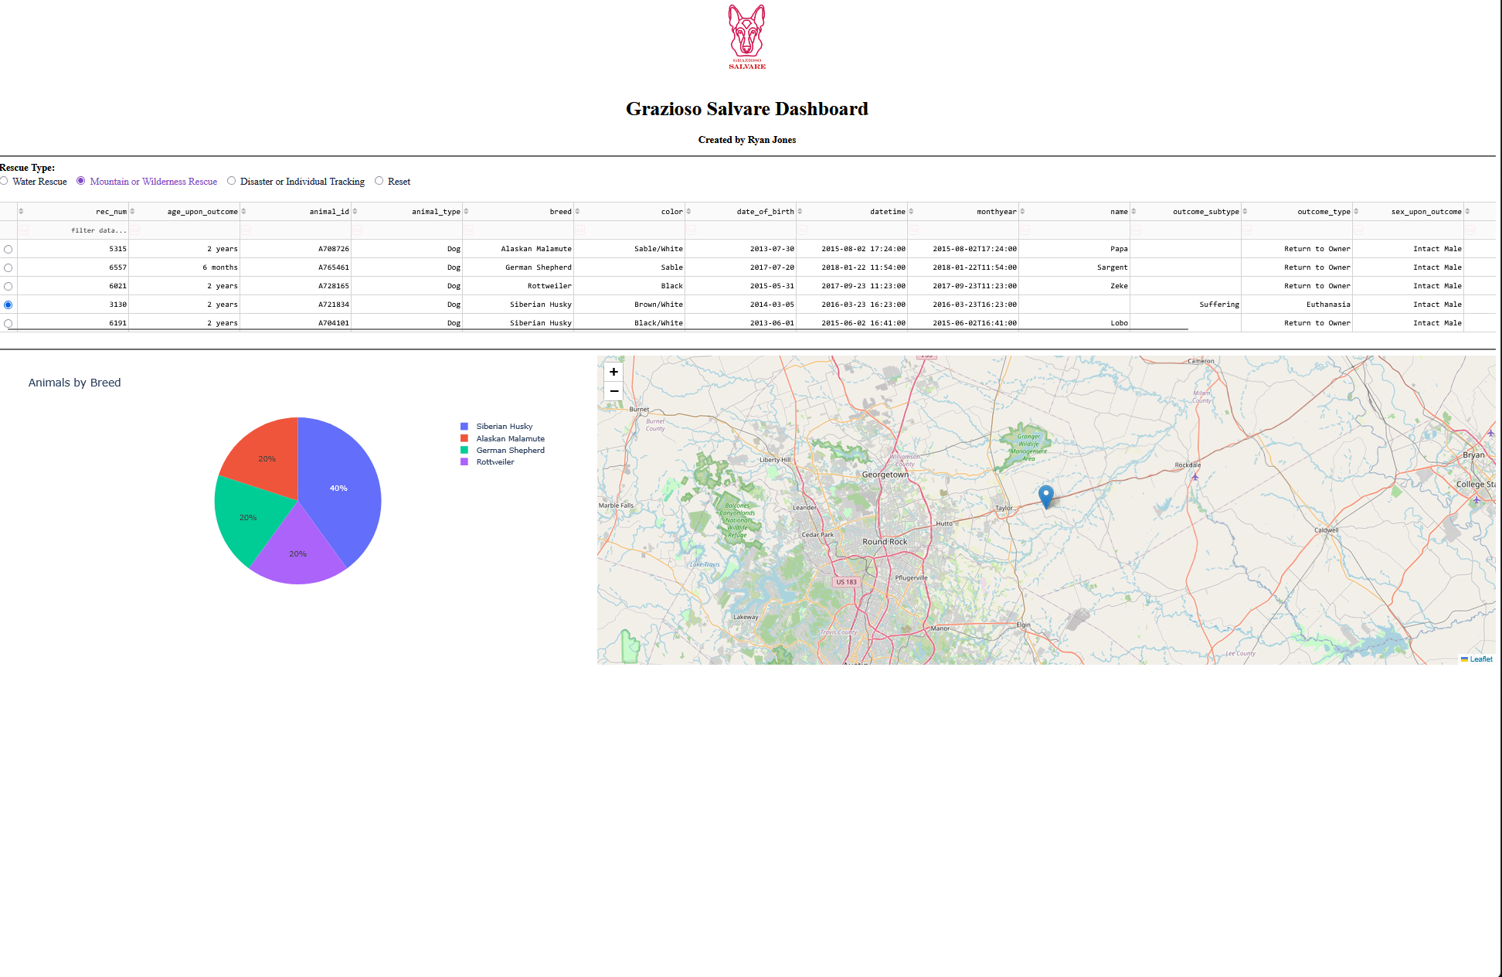
Disaster Filter

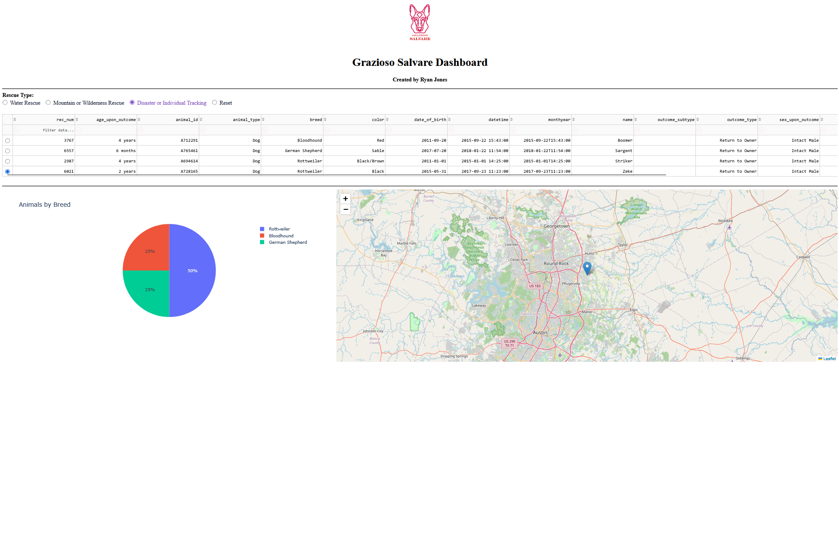
Individual Selection Filter

Dashboard Reset

Contact
Your name: Ryan Jones

